**Book-A-Vintage**

**Web Application project**

**User Manual**

Sravani Kannelur

ID :800967996

**Table of Contents**

1. Who are the Users? 3

1. User’s Need 3
2. How the ‘**Book-A-Vintage’** application works? 3

**Who are the Users?**

* There are two types of users in this web application. They are as follows:

1. Customer
2. Administrator

* Customer can login into my application and check the available vintage cars. He can book any car as per his need of availability as well as cancel it as per his/her availability. Also, he/she can view his/her booking.
* Administrator logs in into application and answers all the queries posted by the customers.

**User’s Need:**

This application will be helpful to customers who have a dream of traveling in vintage car and wants to book it as per his/her availability. He / She can create an account and login into the web application and book his desired vintage car.

**Working of ‘Book-A-Vintage’ application represented through series of pages:**

1. **Home Page:**

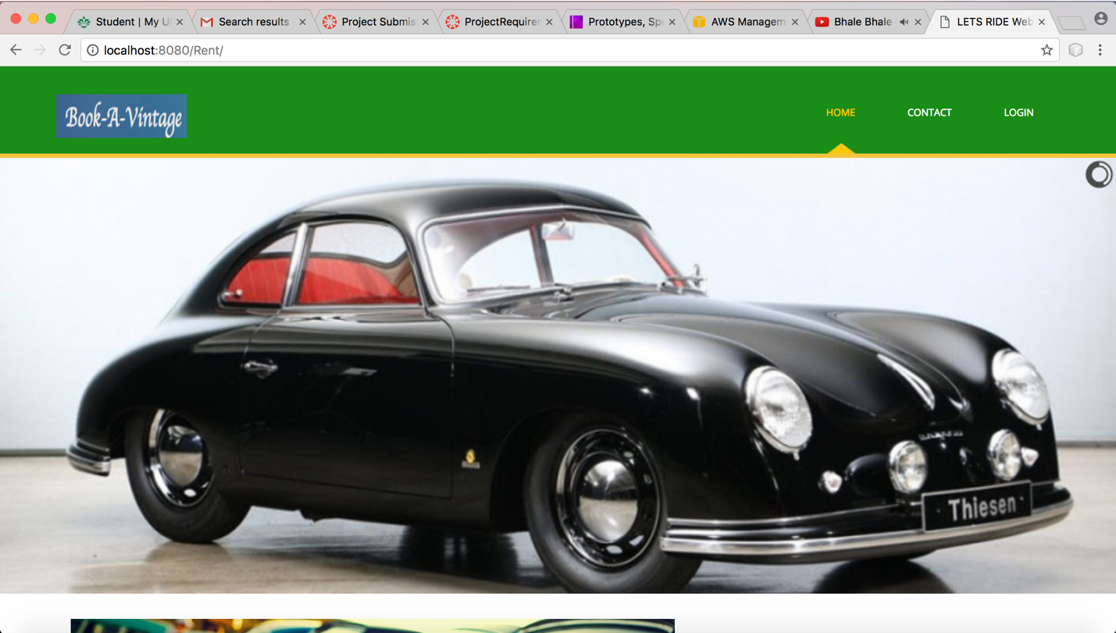

This is the home page of the web application. Through this page we can route to login page, Booking page (or) Registration page. So, if we click on contact tab on the top it will be routed to ‘Contact’ Page.

1. **Contact Page:**

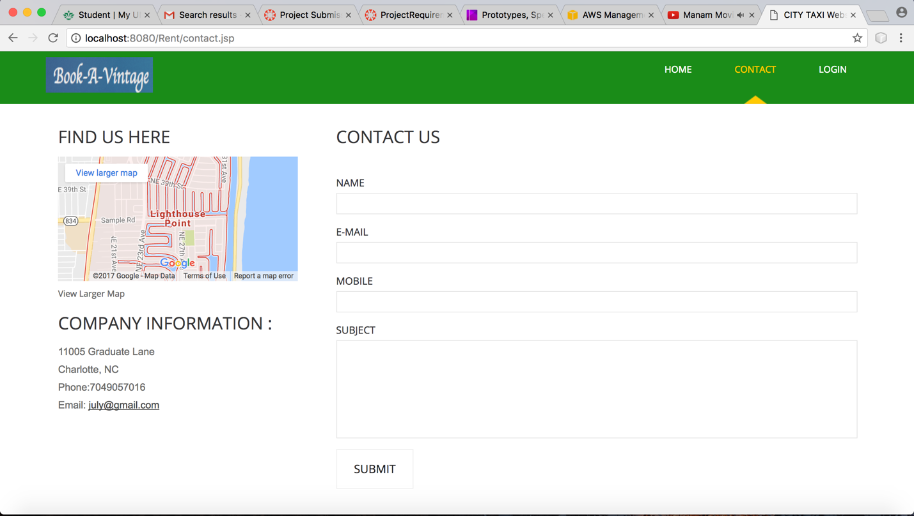

In this page the customer can pose any question and this question will be reflected on to the administrator page.Here, the customer needs to fill the details such as Name, E-mail, Mobile and subject.

Now, if the customer wants to login into web application, he/she can choose login tab at the top.

1. **Login Page**

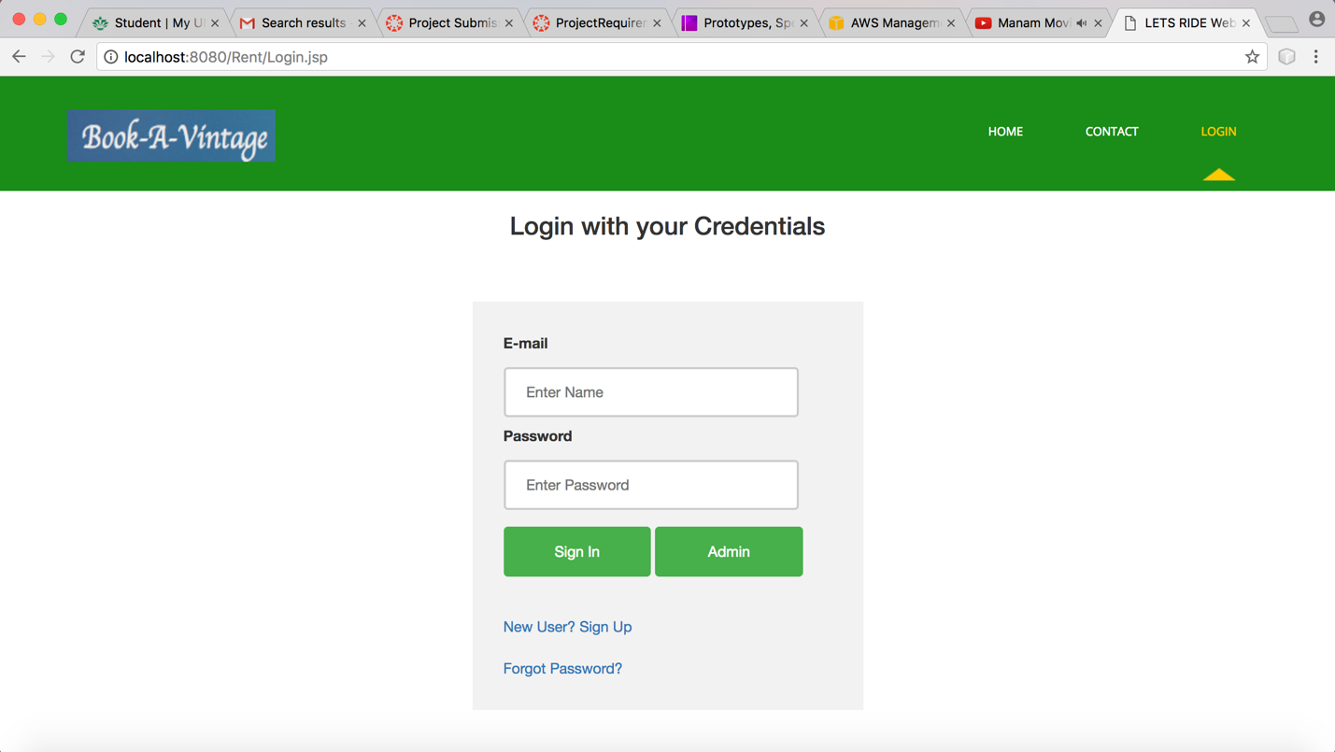

Here, both the customer and administrator can login into web application. He/She needs to give his/her Email and Password. If the user is new to this app he can click ‘New user? Sign Up’ link. On clicking this link, it will be routed to Registration page.

1. **Registration Page:**

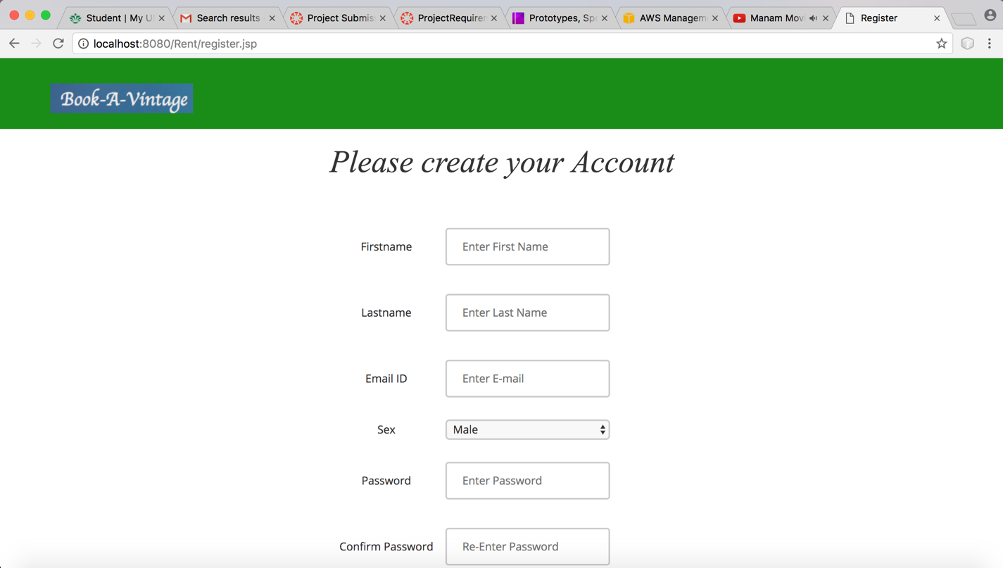

This is the registration screen. Here, the user needs to fill the basic information required to create account. After registration, it will be again routed to login page. For suppose, user had an account but he forgot the password he can click ‘forgot password’ link and it will be redirected to Forgot password page.

1. **Forgot password page:**

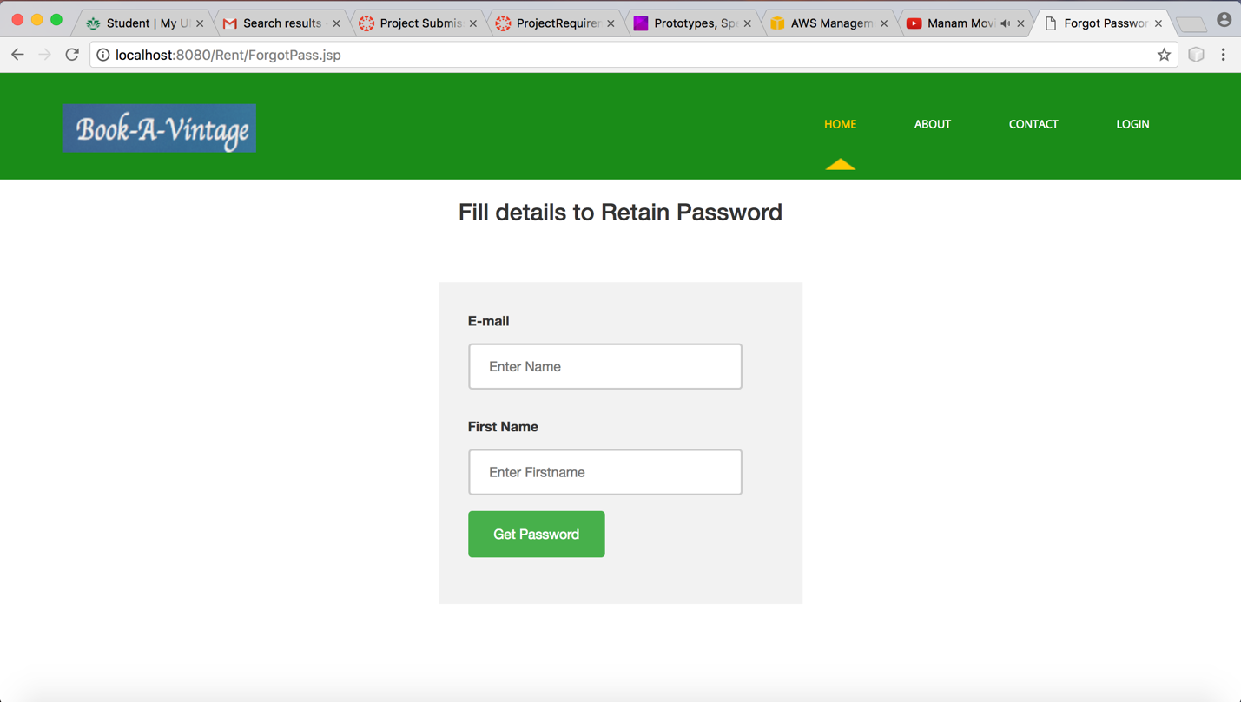

This page asks for email and first name given by the user during registration. If he/she correctly gives all the details, then he would be receiving an email to his registered email.

1. **Recovery Mail:**

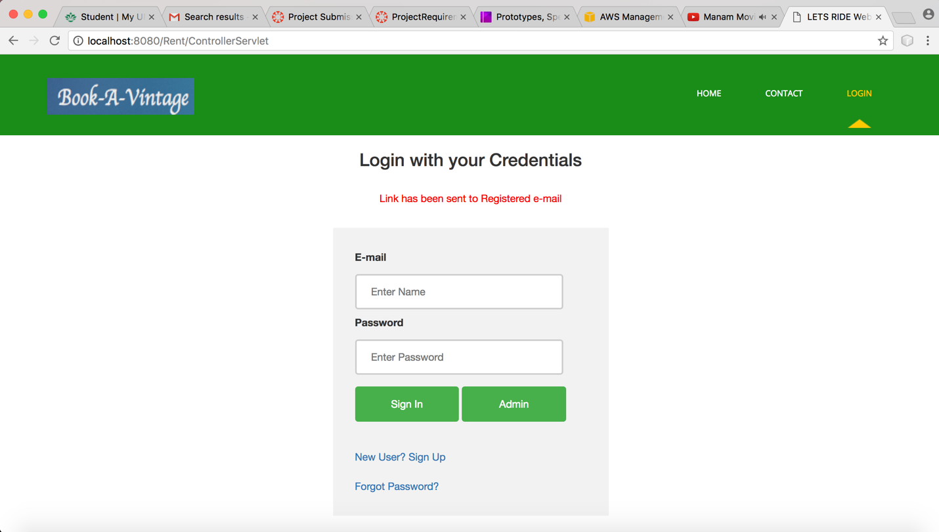

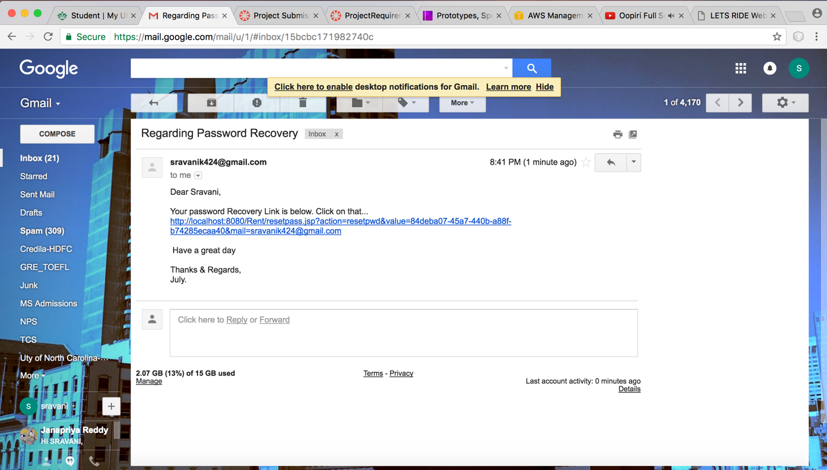

Clicking on this link will route to generate Password Page.

1. **Generate Password**

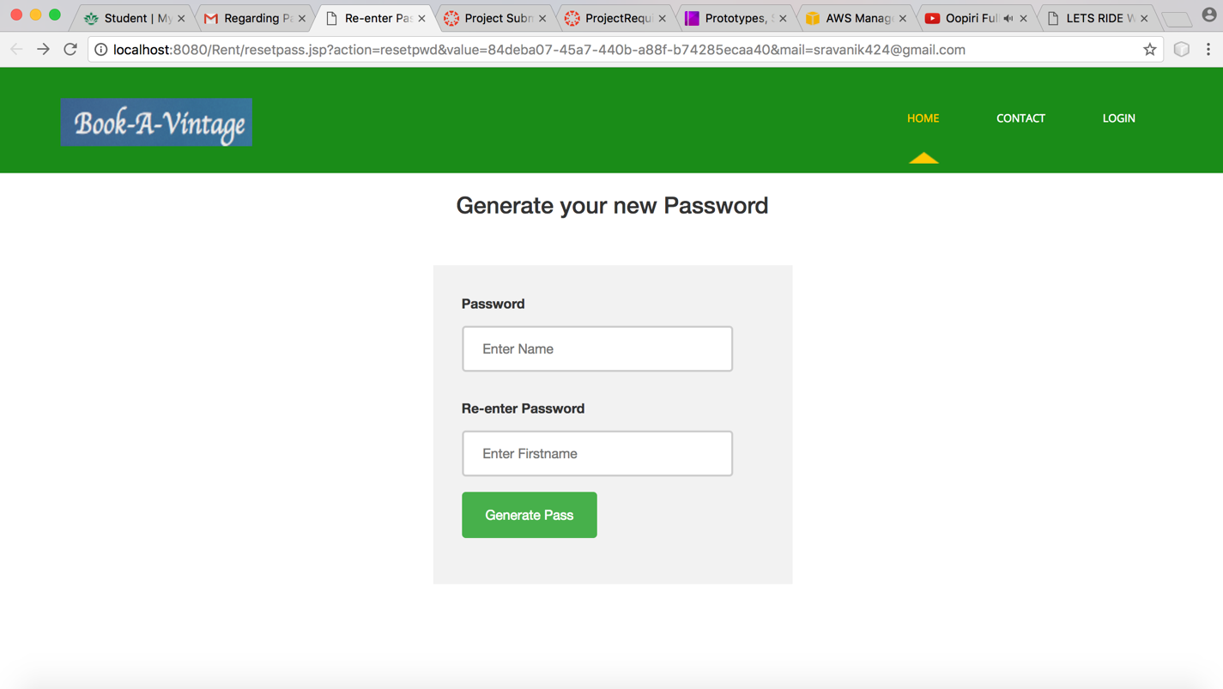

Here, the customer can give password & confirm password. This will update his user credentials. Upon setting the password this page will be routed to Login Page. After giving correct credentials, it will take you to Select Car Page.

1. **Select Car page:**

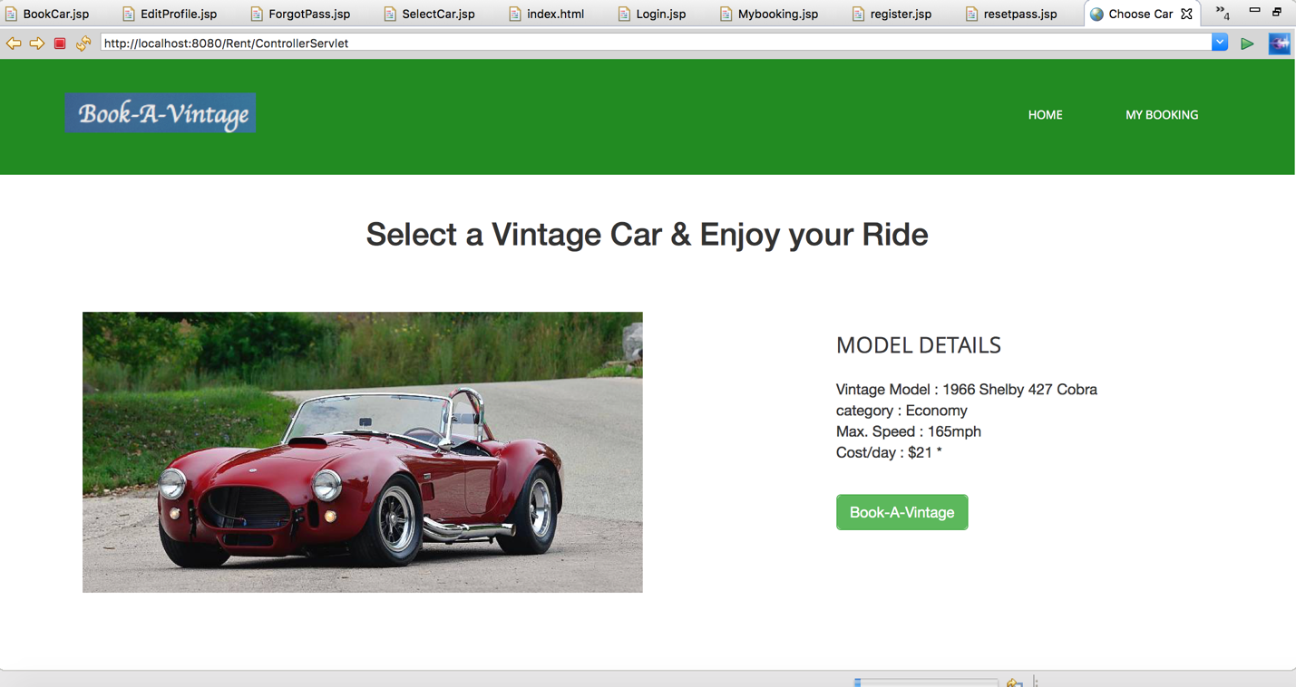

This page will show all the basic details of the car. The user can choose any car he desired of. After clicking ‘Book-A-Vintage’ button, it will route to Book Car page.

1. **Book Car page:**

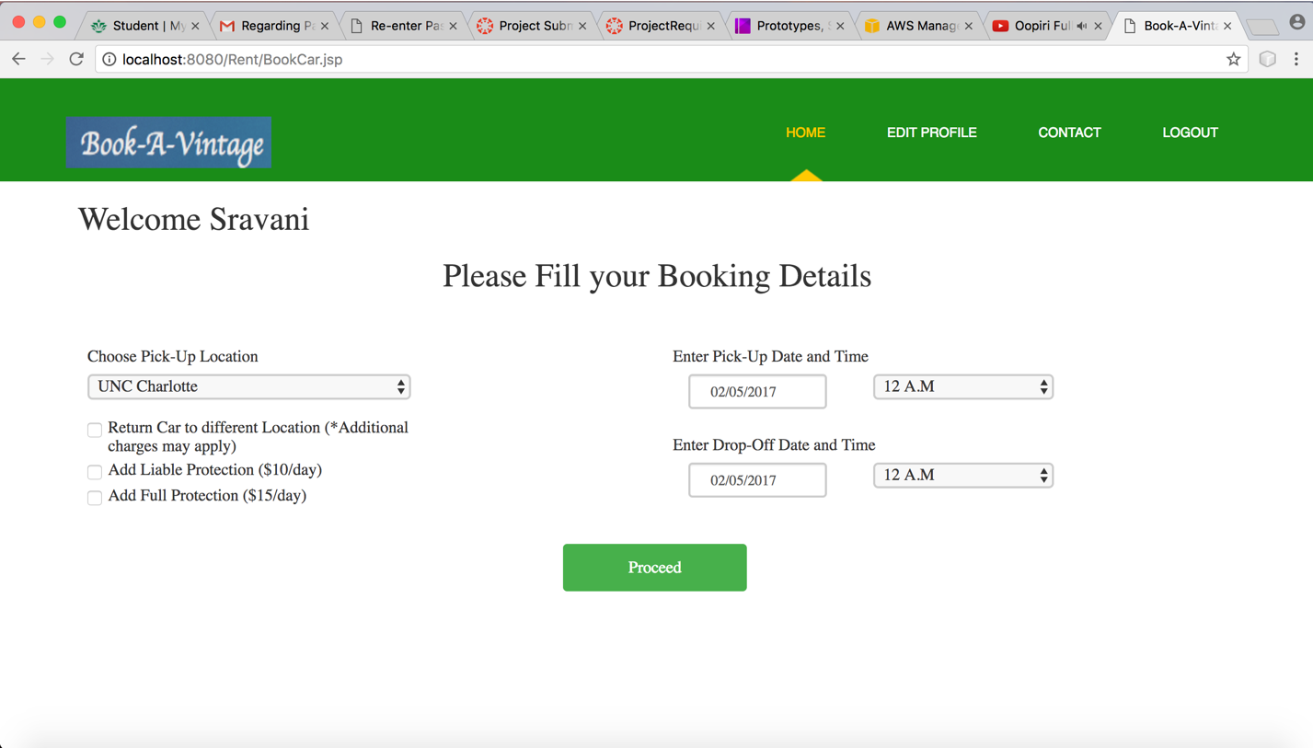

Here, the customer needs to give the details of location, Pick-Up date, Pick-up time, Drop-off date and Drop-date and Drop-off time. He can choose liability options as well. On clicking Proceed button, it will be routed to Confirm Booking page.

1. **Confirm Booking page:**

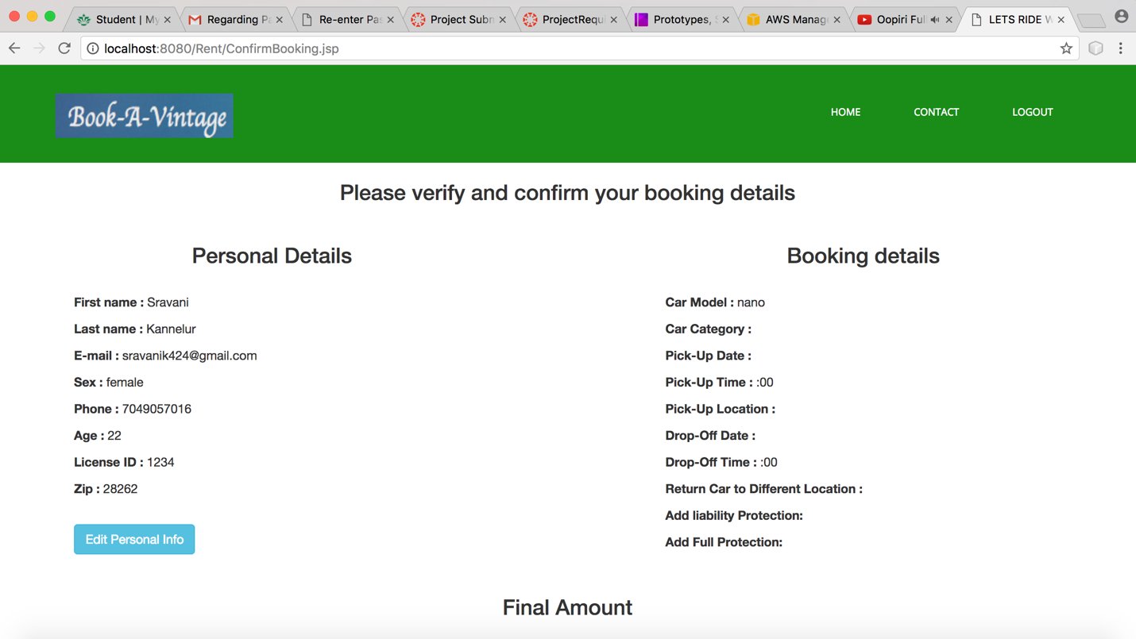

This page gives all the details of the personal as well as customer’s booking information. If any of the personal information is wrong, then he/she can choose edit personal info button. Upon clicking that button, it will route to Edit Profile page.

1. **Edit Profile page:**

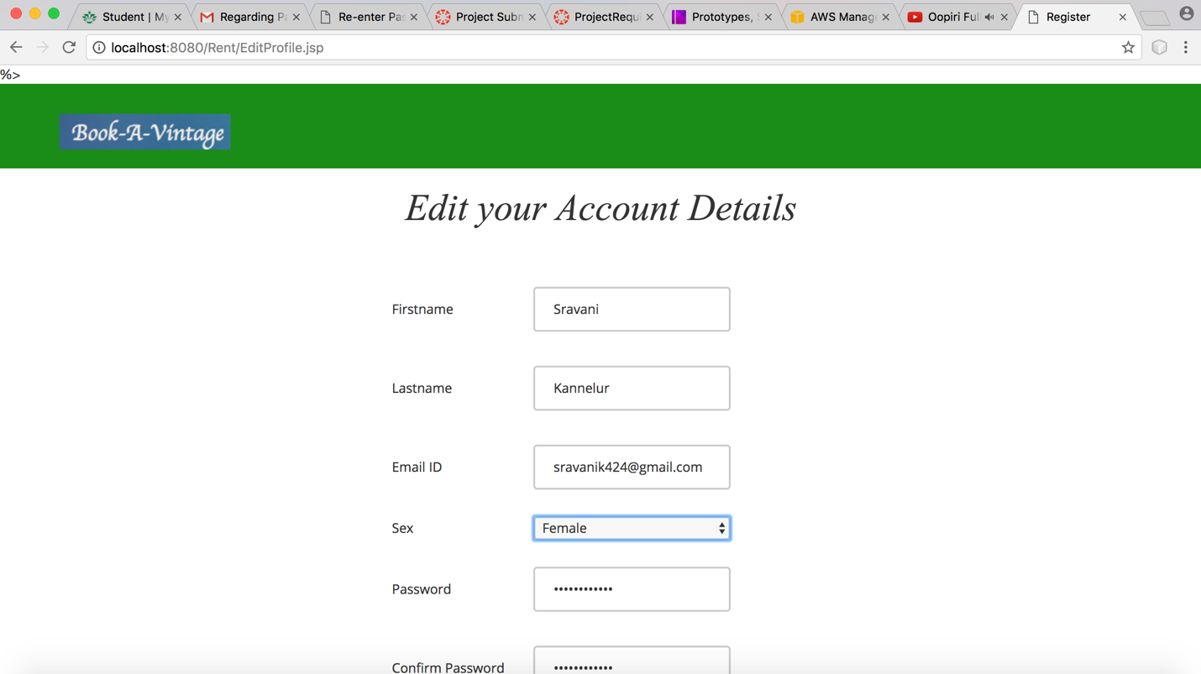

Here, the customer can edit his personal profile except e-mail. After updating, it will route to Confirm booking page. On clicking Confirm button, the ride will be booked.

1. **Admin Login page:**

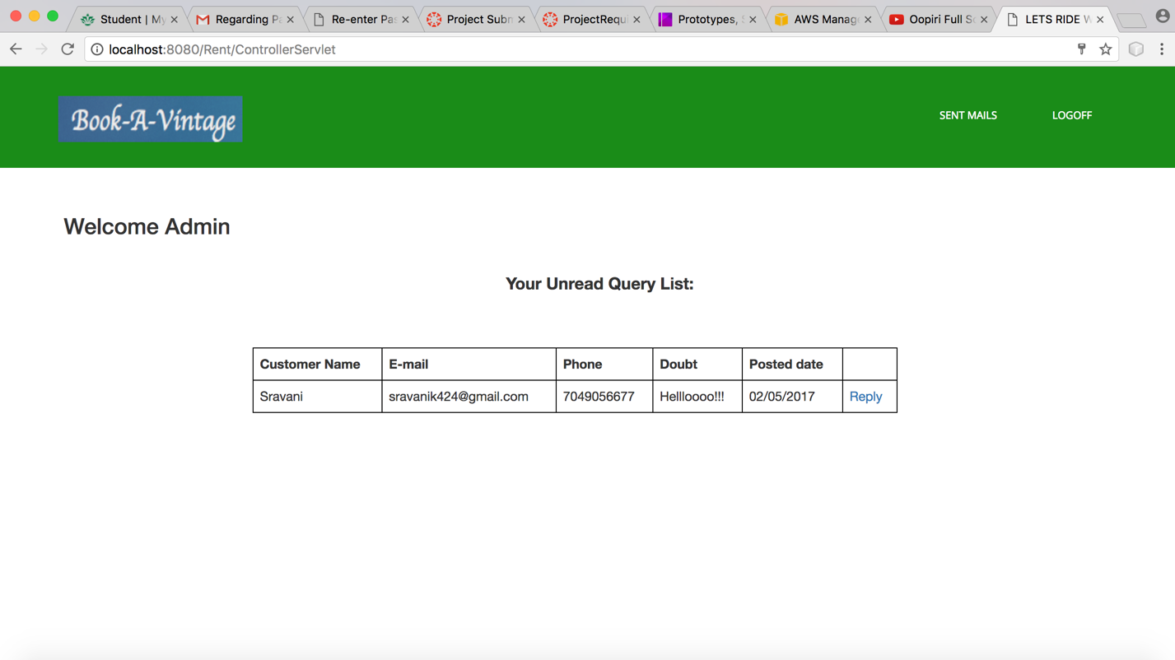

Upon logging in, the administrator will see the queries in a list. If the administrator clicks reply button, it will route to Reply page.

1. **Reply Page:**

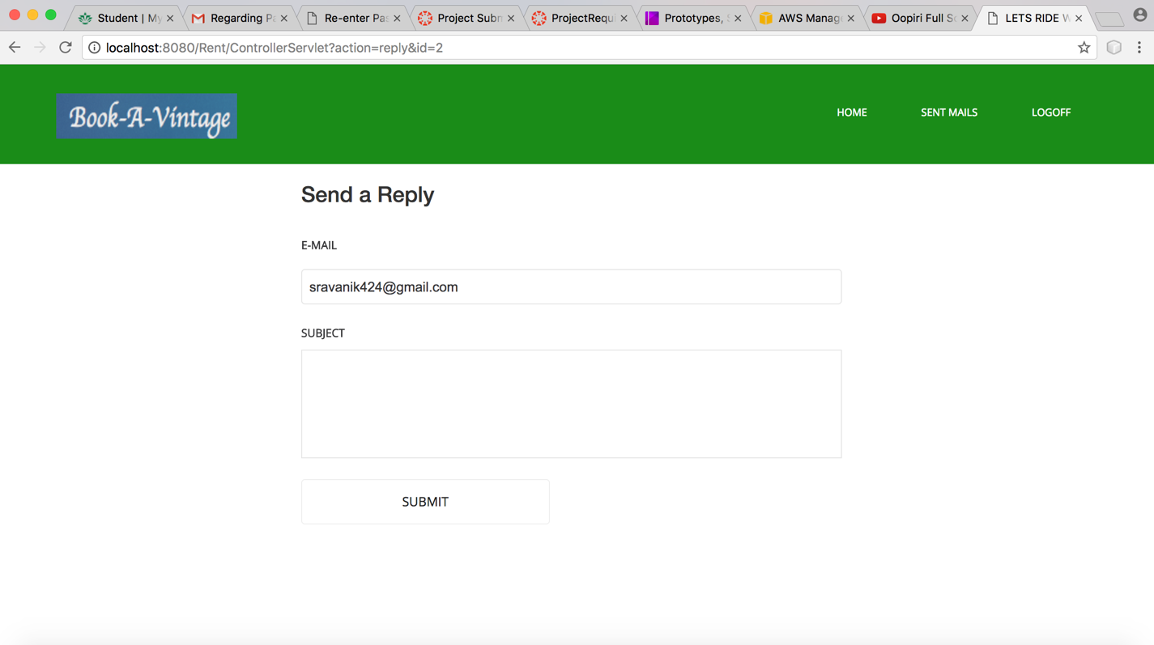

The administrator can write the reply in the subject field and press submit button to send. The administrator’s reply will be mailed to customer’s E-mail ID.